Sample Paper
FINALTERM EXAMINATION
Fall 2025
CS402 - Theory of Automata

Student Must Attempt All Given Questions
No question choice is available

Time: 90 min
Marks: 60

Question No: 1 (Marks: 01) - Please choose the correct option
What is “y” in pumping lemma version 1?
- It is a non-null string (from lec no. 26 and page no.73)
- It is a null-able string
- It is a non-null string with initial state
- It is a null-able string with initial state

Reason:
In Pumping Lemma (Version 1 for Regular Languages), the string is divided as:
w = xyz
with these conditions:
- ∣y∣> 0 → y must be non-empty (non-null)
- ∣xy∣≤ p
- xy^{i}z∈L for all i ≥ 0
There is no condition about the initial state in the definition of y.

Question No: 2 (Marks: 01) - Please choose the correct option
Which of the following is true about Myhill Nerode Theorem.
- L partitions ∑ * into distinct classes (from lec no. 27 and page no.75)
- L partitions ∑ * into same classes
- L partitions ∑ * into distinct functions
- L partitions ∑ * into same functions

Question No: 3 (Marks: 01) - Please choose the correct option
Using De-Morgan's law for sets, which of the following is correct for L1 and L2
- (L1 ^{c} ∪ L2 ^{c} ) ^{c} = (L1 ^{c} ) ^{c} ∩ (L2 ^{c} ) ^{c} (from lec no. 24 and page no.67)
- (L1 ^{c} ∪ L2 ^{c} ) = (L1 ^{c} ) ^{c} ∩ (L2 ^{c} ) ^{c}
- (L1 ^{c} ∪ L2 ^{c} ) ^{c} = (L1 ^{c} ) ∩ (L2 ^{c} )
- (L1 ∪ L2 ) ^{c} = (L1 ^{c} ) ^{c} ∩ (L2 ^{c} ) ^{c}

Reason
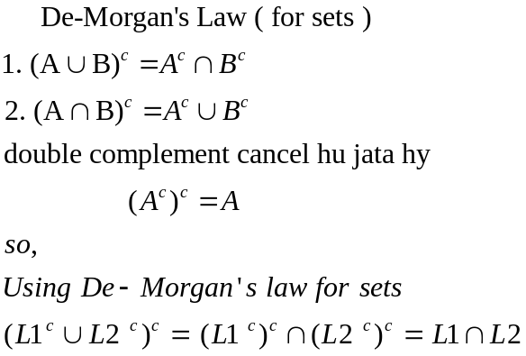

Question No: 4 (Marks: 01) - Please choose the correct option
What is the minimum number of states an FA must have to recognize a language L if there are n distinguishable strings in Σ*?
- Less than n states
- Exactly n states
- More than n states
- At least n states (from lec no. 19 and page no.53)

Reason

Number of states in minimal FA = number of distinguishable strings (equivalence classes)

Question No: 5 (Marks: 01) - Please choose the correct option
Which of the following machine do not have an ability to accept a Language?
- Moore machine
- Finite automata
- Non-deterministic Finite automata
- Transition graph

Reason

- Moore & Mealy → Output machines (do NOT accept languages)
- DFA & NFA → Language accepting machines

Question No: 6 (Marks: 01) - Please choose the correct option
Which of the following is used to make an incrementing machine?
- Moore machine
- Mealy machine
- Finite automata
- Turing machine

Question No: 7 (Marks: 01) - Please choose the correct option
What is the 1's complement of 10101100?
- 10101000
- 00101000
- 01101110
- 01010011

Question No: 8 (Marks: 01) - Please choose the correct option
What is the purpose of an incrementing machine?
- Addition of binary numbers
- Subtraction of binary numbers
- Multiplication of binary numbers
- Division of binary numbers

Question No: 9 (Marks: 01) - Please choose the correct option
What can be built using a complementing machine and an incrementing machine?
- Addition of binary numbers
- Subtraction of binary numbers
- Multiplication of binary numbers
- Division of binary numbers
Question No: 10 (Marks: 01) - Please choose the correct option
Moore and Mealy machines are said to be equivalent for an input string if:
- They print the same output string
- They have the different output string
- They have the same transition table
- They have the same transition diagram
Question No: 11 (Marks: 01) - Please choose the correct option
What happens to the output character of a state if there is no incoming transition at that state in a Mealy machine?
- It is ignored
- It is printed
- It is converted to a Moore machine
- It is converted to a loop

Question No: 12 (Marks: 01) - Please choose the correct option
Which of the following is true about non regular language?
- A language that can be expressed by a regular expression
- A language that cannot be expressed by any regular expression
- A language that can only be expressed by a finite automaton
- A language that can only be expressed by a Mealy machine

Question No: 13 (Marks: 01) - Please choose the correct option
What is the purpose of Pumping Lemma?
- To prove that a language is non regular
- To prove that a language is regular
- To prove that a language is finite regular
- To prove that a language is infinite regular

Question No: 14 (Marks: 01) - Please choose the correct option
Which of the following language is regular?
- a(a+b)*b
- a^{n}b^{n}
- a^{n}b^{n}c^{n}
- a^{n}b^{n}c^{n}d^{n}

Question No: 15 (Marks: 01) - Please choose the correct option
If a problem have no decision procedure, then that problem is called ________ problem.
- Decidable
- Undecidable
- Regular
- Infinite

Question No: 16 (Marks: 01) - Please choose the correct option
If X is a regular language, and Y is any language (regular/non-regular), then Pref(Y in X) is a _________ language.
- Non defined
- Non-regular
- regular
- non-existing

Question No: 17 (Marks: 01) - Please choose the correct option
To test whether FA accepts any word, we have to test at least one word of length that is _________ to its total number of states. If one word will be accepted, then FA accepts a word.
- less than
- greater than
- equal to
- not equal to

Question No: 18 (Marks: 01) - Please choose the correct option
Consider an FA having X states and a word w. If the FA accepts a word w, such that:
X ≤ length (w) < 2X, then FA accepts ___________ language.
- Finite regular
- Finite non-regular
- Infinite non-regular
- Infinite regular

Question No: 19 (Marks: 01) - Please choose the correct option
Which of the following is Not a part of a Context Free Grammar?
- Non-terminal
- Pre Terminal
- Production
- Terminal

Question No: 20 (Marks: 01) - Please choose the correct option
Which of the following word is accepted by the following CFG?
S--- abSb | aS | bS | a | b | ^
- abbabba
- aaaabbb
- bbbbaaa
- abababb

Question No: 21 (Marks: 01) - Please choose the correct option
Select the correct regular expression corresponding to the following CFG.
Σ = {u, v}
S--uS|vS|u|v|^

- u(u+v)*v
- v(u+v)*u
- vu(u+v)*
- (u+v)*

Question No: 22 (Marks: 01) - Please choose the correct option
Consider the following CFG:
S → pZq|qZp
Z → pZ|qZ|Λ
The above CFG accept the language that ______________.

- Begin with q and ends with p
- Begin and ends with same letters
- Begin and ends with different letters
- Begin with p and ends with q

Question No: 23 (Marks: 01) - Please choose the correct option
Which of the following is Not true about Chomsky Normal Form?
- Unit production exist in the Chomsky Normal Form
- Null production is not exist in the Chomsky Normal Form
- Two non-terminals exist at the left side of production in Chomsky Normal Form
- Only one terminal exist at the right side of production in Chomsky Normal Form

Question No: 24 (Marks: 01) - Please choose the correct option
Which of the following is the correct final result of the following expression:
*+*7512
- 15
- 71
- 38
- 72

Question No: 25 (Marks: 01) - Please choose the correct option
Consider the following CFG and identify a semiword from the given options.
S → XX|00|11|0|1|^

- 00
- 0011
- 0011X
- 11

Question No: 26 (Marks: 01) - Please choose the correct option
If we have a CFG, in which all the productions are in this form:
Nonterminal------ semiword
Nonterminal------ word
Then the language that is accepted by such CFG, will be ___________ language.
- Non-regular
- Infinite non-regular
- Finite non-regular
- regular

Question No: 27 (Marks: 01) - Please choose the correct option

Consider the following CFG and remove the unit production from it, then select the correct option which has the correct updated CFG.
S → X|00|^
X → 0 | ^

- S → X|00, X → 0
- S → X|^, X → ^
- S → 00|^, X → ^
- S → 0|00|^, X → 0 | ^

Question No: 28 (Marks: 01) - Please choose the correct option
Halt states in PDA can be:
- START, PUSH
- PUSH, REJECT
- ACCEPT, REJECT
- READ, POP

Question No: 29 (Marks: 01) - Please choose the correct option
Non-terminal is called self-embedded if it occurs in a tree as a:
- Root
- Leaf
- Descendant
- Edge

Question No: 30 (Marks: 01) - Please choose the correct option
Which of the following is dead production:
- X->a
- A->XY
- Y->AB
- S->AX
Question No: 31 (Marks: 01) - Please choose the correct option
is a set of rules showing which state is to be entered when a letter is read form the TAPE and what character is to be printed in a Turing Machine.
- Terminals
- Program
- Non-terminals
- Tape Head

Question No: 32 (Marks: 01) - Please choose the correct option
subprogram removes the character at any location on a TAPE.
- INSERT
- UPDATE
- DELETE
- SUM

Question No: 33 (Marks: 01) - Please choose the correct option
IN CNF, there must be non terminals at the right side of the production.
- One
- Two
- Three
- Four

Question No: 34 (Marks: 03)
Construct CFG for the regular expression a (a+b)⁺.
Answer

Question No: 35 (Marks: 03)
Convert the following CFG into CNF.
- > aX | bX
X-> a
Answer

Question No: 36 (Marks: 03)

Consider the following CFG:
S-- pAqr
A--pA| qA| ^
Draw the derivation tree for the string “ppqppqr”.

Answer

Question No: 37 (Marks: 03)
Consider the following CFG:
S-- 1A01
A--0A| 1A| ^
You are required to mention that whether the following strings are accepted by the above CFG:
- 100001010
- 011101111
- 100011101

Answer

Question No: 38 (Marks: 05) - Please choose the correct option

Consider the two TGs, TG1 and TG2. Write the procedure to make TG3 which can accept L1+L2 generated by TG1 and TG2. No need to make diagram.

Answer

Question No: 39 (Marks: 05)
Write the corresponding Context Free Grammar for the given Transition Graph (TG).
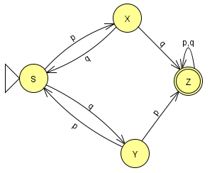
Answer

Question No: 40 (Marks: 05) - Please choose the correct option
Consider the following Moore machine having:
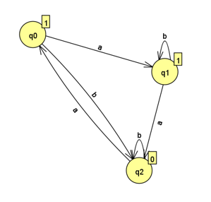
The states q0, q1, q2 where q0 is the start state
Σ = {a,b},
Γ={0,1}
Run the string “aabbabbab” on the above Moore machine and write the output string against the given input.

Answer

